SOFTWARE REQUIREMENTS SPECIFICATION
FOR
A Web-Based Online Document Management System for Department of Student Affairs in JHCSC Pagadian Campus

Prepared by:
Impil, Marc Jaypee
Tabaranza, Famme
Upao, Raymart

Submitted in fulfillment of requirements for Integrative Programming and Technologies 2 (IT305)
December 17, 2025

Table of Contents
1. Introduction
1.1 Purpose
1.2 Intended Audience
1.3 Product Scope
1.4 Definitions, Acronyms, and Abbreviations
2. Overall Description
2.1 User Characteristics
2.2 Constraints
2.3 Assumptions and Dependencies
3. Requirements Specifications
3.1 Functional Requirements
3.2 Non-Functional Requirements
3.3 External Interface Requirements
3.4 System Models
3.5 Database Design
3.6 Implementation
3.7 Testing and Deployment

1. Introduction
1.1 Purpose
This project aims to develop a web-based document management system that facilitates online submission, processing, status monitoring to enhance the administrative processes of the Department of Social Affairs at JHCSC Pagadian Campus.
1.2 Intended Audience
The intended users of this system include students, departments, and old/new organizations within JHCSC Pagadian Campus who need to submit, process, and track documents such as accomplishment reports, vehicle pass applications, and organization renewals.
1.3 Product Scope
The system will provide a digital platform for document submission and tracking, offering real-time status notifications, and transparent processing to reduce delays, prevent misplacement of documents, improve communication, and ensure efficient service delivery between students, departments, and organizations.
1.4 Definitions, Acronyms, and Abbreviations
JHCSC – Josefina H. Cerilles State College
DSA – Department of Student Affairs / Social Affairs
Document Management System – A software system that organize, tracks, and processes electronic documents

2. Overall Description
2.1 User Characteristics
Students and Organization – Submit request or application form with provided requirements and monitor approval status for personal and academic needs.
Departments – Receive, review, update user role, and process digital submissions while providing timely updates to students with email notification.
2.2 Constraints
- Requires stable internet connectivity for access.
- Limited to JHCSC Pagadian Campus users with valid credentials.
- Data privacy and security compliance must be ensured.
- Accessibility across devices (desktop and mobile) is expected but may depend on compatibility.
2.3 Assumptions and Dependencies
- Users will have access to digital devices and internet connection.
- The system depends on server availability and campus IT infrastructure.
- Integration with existing school databases and authentication services will be supported.
- Administrative staff will cooperate in updating and maintaining the system’s workflow

3. Requirements Specifications
3.1 Functional Requirements
1. User Account Management
- The system shall allow users to register an account.
- The system shall allow users to log in and log out securely.
- The system shall store user information such as student ID, full name, email, course, and role.
2. Document Request Management
- The system shall allow users to submit document requests.
- The system shall allow users to select document types during request creation.
- The system shall store request details, including purpose, submission date, and status.
3. Application Form Handling
- The system shall allow users to fill out dynamic application forms based on document type.
- The system shall allow users to submit completed application forms.
- The system shall store form field values linked to each request.
4. File Upload Functionality
- The system shall allow users to upload required supporting documents.
- The system shall store file details such as file name, file path, file size, and MIME type.
- The system shall validate uploaded files based on allowed file types and size limits.
5. Request Status Tracking
- The system shall allow users to view the status of their own requests.
- The system shall notify users through email notifications when their request status changes.
6. Admin Management Features
- The system shall allow the admin to log in to the admin dashboard.
- The system shall allow the admin to view all user requests.
- The system shall allow the admin to update request statuses (e.g., Pending, Approved, Rejected).
- The system shall allow the admin to add notes to user requests.
7. Document Type Management (Admin)
- The system shall allow the admin to create new document types.
- The system shall allow the admin to edit existing document types.
- The system shall allow the admin to upload document templates.
8. Dynamic Form Configuration (Admin)
- The system shall allow the admin to create and manage dynamic form fields.
- The system shall allow the admin to set required document upload rules.
9. User Management (Admin)
- The system shall allow the admin to view all registered users.
- The system shall allow the admin to edit user account information.

10. Request Deletion
- The system shall allow users to delete pending requests that are not yet processed.
3.2 Non-Functional Requirements
1. Performance
- The system shall respond to user actions within 2–3 seconds under normal load.
- The system shall support multiple simultaneous users without system failure.
2. Security
- The system shall use password hashing to securely store login credentials.
- The system shall enforce role-based access control (RBAC) for user and admin functionalities.
- The system shall protect against SQL injection, XSS, and CSRF attacks.
3. Usability
- The system shall provide an easy-to-use and intuitive interface.
- The system shall be usable by non-technical users without prior training.
4. Reliability
- The system shall provide at least 99% uptime.
- The system shall handle unexpected errors gracefully without data loss.
5. Scalability
- The system shall be scalable to support increasing numbers of users and requests.
- The system database shall efficiently handle large numbers of stored files and records.
6. Compatibility
- The system shall be accessible using modern web browsers (Chrome, Firefox, Edge).
- The system shall be usable on desktop and mobile devices.
7. Maintainability
- The system shall be developed using modular code architecture.
- The system shall support easy updates and improvements.
8. Audit and Logging
- The system shall log user actions and admin activities.
- The system shall record timestamps for data creation and modification.
3.3 External Interface Requirements
1.1 General User Interface
- The system shall provide a web-based interface accessible through standard web browsers.
- The system shall use a clean and consistent layout for all pages.
- The system shall display clear labels, icons, and instructions for all input fields and buttons.

1.2 User Interfaces – Student/User Side
The system shall provide the following user screens:
- Registration Page
  - Input fields for Full Name, Student ID, Email, Course, and Password.
- Login Page
  - Fields for Email and Password.
- Dashboard
  - Display user profile information.
  - List of submitted document requests.
- Document Request Page
  - Dropdown for selecting document type.
  - Text field for purpose of request.
- Dynamic Application Form Page
  - Manual setting up form fields based on selected document type.
- File Upload Page
  - Upload buttons for required documents.
  - Display of uploaded file names and statuses.
- Request Status Page
  - Shows request status.
  - Displays admin notes.
1.3 Admin Interfaces
The system shall provide the following admin screens:
- Admin Dashboard
  - Overview of total users and requests.
- Request Management Page
  - Table view of all user requests.
  - Buttons to approve, reject, or update status.
- Document Type Management Page
  - Forms for creating and editing document types.
- Dynamic Form Builder Interface
  - UI for adding, deleting, and reordering form fields.
- User Management Page
  - Table view of registered users.
  - Edit user information functions.
2. Hardware Interface Requirements
- The system shall run on devices such as:
  - Desktop computers
  - Laptops
  - Tablets
  - Smartphones

- The system shall require:
  - At least 2 GB RAM
  - Modern browser-supported device
- The server shall require:
  - Reliable storage for uploaded documents.
3. Software Interface Requirements
3.1 Operating System Interfaces
The system shall support:
- Windows
- macOS
- Linux
- Android
- iOS (via web browser)

3.2 Database Interfaces
- The system shall use a relational database (e.g., MySQL or similar).
- The system shall interface with the following database tables:
  - users
  - requests
  - document_types
  - required_documents
  - document_form_fields
  - application_form_data
  - uploaded_files
3.3 External Services Interface
- The system shall integrate with an email service for sending notifications.
- The system shall interface with a file storage system for saving uploaded documents.
4. Communication Interface Requirements
- The system shall use the HTTP/HTTPS protocol for communication.
- All sensitive data shall be transmitted using SSL/TLS encryption.
- The system shall support RESTful communication between frontend and backend.
5. Security Interface Requirements
- The system shall support secure authentication interfaces.
- The system shall enforce role-based access between user and admin interfaces.
- The system shall terminate inactive sessions automatically.
3.4 System Models
Use Case
The Use Case Diagram illustrates the functional requirements of the system and how different types of users interact with it.
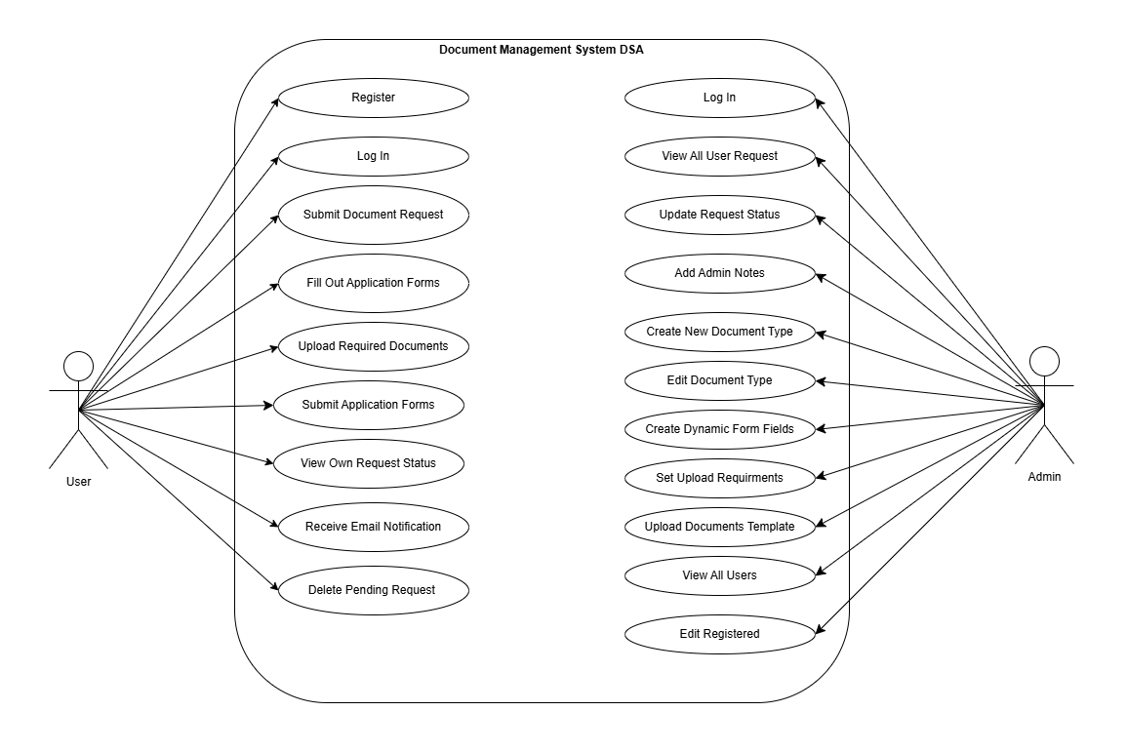

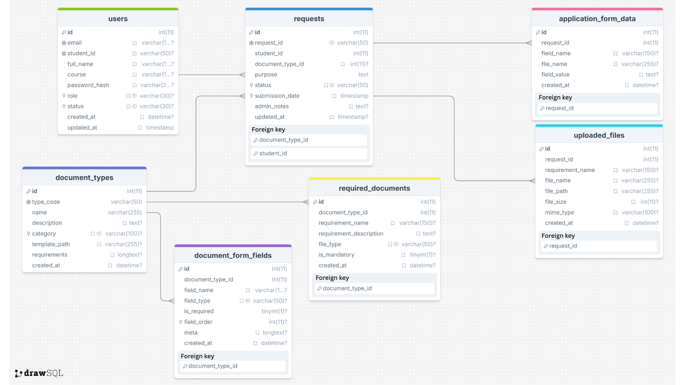
3.5 Database Design

3.6 IMPLEMENTATION
Development Environment:
The system was developed primarily using laptops as the main development devices. Visual Studio Code served as the primary code editor for writing and managing the system’s source code. All system files were hosted locally using Apache24, while XAMPP was utilized as the server environment with MySQL functioning as the database management system. This configuration enabled the team to efficiently develop, test, and execute the system within a local environment.
Programming Languages:
The development of the system involved several programming languages, including HTML, CSS, JavaScript, and PHP.
- HTML and CSS were utilized for the layout design and overall structure of the web pages.
- JavaScript enhanced interactivity and responsiveness across the user interface.
- PHP handled the connection between the front-end and back-end, processing and displaying data from the database. Meanwhile, MySQL served as the storage and management system for all records and information used by the application.
Framework:
No external framework was applied during the system’s development. Instead, it was manually coded using pure HTML, CSS, JavaScript, and PHP.
Tools Used:
Several development tools were employed to facilitate and streamline the system creation process.
- XAMPP
- Composer
- Git/Github
- Visual Studio
3.7 Testing and Deployment

Table 1: Load Test Performance Metrics
System context: The Student Affairs Document Management System is a web-based platform that allows students and staff at JHCSC Pagadian Campus to submit, track, and manage official documents such as accomplishment reports, vehicle pass applications, and organization renewals. Our Stress test simulated concurrent student access during peak periods when document submissions are highest.
Metrics measured: Average API response time in milliseconds. Measured using inspect network time for each individual request.
Testing environment: Manual testing was conducted on a local development machine running XAMPP (Apache 2.4.58, PHP 8.2.12, MySQL 8.0) and Web Browser on Windows 11. All requests were sent to localhost.
Database load (record) | Average Response Time (milliseconds) | System Performance Observation
100 records | 4990ms | Extremely high latency from the very first requests. Each API call takes ~5 seconds to complete already unacceptable for user-facing operations.
1,000 records | 4990ms | No performance degradation as volume increases 10x. Response time remains constant, indicating the bottleneck is per-request overhead, not cumulative load or resource exhaustion.
10,000 records | 4930ms | Still perfectly stable. Slight 60 ms improvement possibly due to MySQL query cache taking effect. Zero failed requests.
50,000 records | 4930ms | System continues to handle 50x the initial load with exactly the same average response time. No timeouts, no errors but ~4.9-second API latency makes real-time interaction impossible.

The results from Table 1 demonstrate remarkable stability across a wide range of request volumes. At 100 requests, the average response time was 4,990 ms, indicating extremely high per-request latency from the outset. As the load increased to 1,000, 10,000, and even 50,000 requests, the average response time remained virtually unchanged at approximately 4,930 - 4,990ms. No performance degradation, timeouts, or failed requests were observed, even at 50 times the initial load.
This consistency reveals that the system scales exceptionally well in terms of throughput and resource management under sequential load. The absence of degradation suggests effective utilization of caching mechanisms, as MySQL query cache, preventing resource exhaustion. However, the core bottleneck is a persistent per-request overhead of nearly 5 seconds, rendering the system unsuitable for interactive user operations where response times exceeding 2 seconds significantly impair user experience. Therefore, optimization efforts must focus on profiling and optimizing individual API endpoints, enhancing query efficiency, adopting pagination for large result sets, and incorporating connection pooling along with asynchronous processing where applicable to ensure the system maintains acceptable performance and responsiveness during peak document submission periods at JHCSC Pagadian Campus.
Table 2: Stress Test Performance and Breaking Point Analysis
System context: The Student Affairs Document Management System is a web-based platform that allows students and staff at JHCSC Pagadian Campus to submit, track, and manage official documents such as accomplishment reports, vehicle pass applications, and organization renewals. Our Stress test simulated concurrent student access during peak periods when form requesting are highest.
Metrics measured: HTTP time per request (milliseconds) for critical users using the request form with increasing concurrent users.
Testing environment: Stress tests were conducted using Apache Bench CLI on a Windows 11 development machine against a local XAMPP stack (Apache 2.4.58, PHP 8.2.12, MySQL 8.0). The test simulated virtual users accessing the system's request form to measure performance under varying concurrent loads.

Request | Concurrent Users & Actions | Time per request(ms) | Observation & Failure Mode
10,000 requests | 10 User performing:  - Requesting form | 24.612 [ms] | Excellent performance with very low latency. System handles low concurrency efficiently, suitable for off-peak usage. No failures observed.
10,000 requests | 20  User performing:  - Requesting form | 86.869 [ms] | Acceptable response time under moderate concurrency. Slight increase in latency as users double, but still responsive (
10,000 requests | 40  User performing:  - Requesting form | 93.399 [ms] | Stable performance with minimal additional latency when doubling to 40 users. System scales well up to this level without degradation. No failures.
100,000 requests | 50  User performing:  - Requesting form | 262.838 [ms] | Noticeable degradation in response time as total requests increase 10x and concurrency rises. Latency exceeds 250ms, which leads to server failure and database disconnection making the user unable to log In.
Recovery Test  (Return to 10,000  request & 20  users) | 20  User performing:  - Requesting form | 55.695 [ms] | System recovers effectively after high-load stress. Response time improves significantly, indicating no persistent resource exhaustion or damage. Full resilience demonstrated; performance returns to low-latency state. No lingering failures.

The stress test reveals a critical vulnerability in the Student Affairs Document Management System under higher concurrent loads during simulated peak submission periods. With 50 concurrent users performing standard form requests across 100,000 total requests, performance degrades noticeably, resulting in a response time of approximately 263 milliseconds, accompanied by server failures and database disconnections that prevent essential operations such as user login.
The situation escalates to critical failure at this concurrency level, where the increased latency and connection issues indicate that the system's database and server layers struggle to manage simultaneous access effectively. The system's breaking point is effectively reached at 50 concurrent users, at which point it becomes unreliable due to these disconnections and failures, demonstrating that the primary bottleneck is the handling of concurrent operations under heightened load, rather than sequential volume alone.
The successful recovery test, where response times returned to under 56 milliseconds after reducing concurrency to 20 users and total requests to 10,000, confirms that the failure was transient and load-induced, with no evidence of data corruption or permanent damage. This result underscores an urgent need for optimization, including enhanced database connection management, query tuning, and implementation of connection pooling or caching strategies, as the system in its current state cannot reliably support moderate to high multi-user concurrency during peak document submission periods at JHCSC Pagadian Campus.

Survey for Web-Based Online Document Management System for Department of Social Affairs in JHCSC Pagadian Campus (Responses)
Usability
Questions | (5) Strongly Agree | (4) - Agree | (3) Neither Agree or Disagree | (2) Disagree | (1) Strongly Disagree
Evaluation Criteria for Usability [I thought the system was easy to use.] | 14 | 7 | 8 | 1 | 0
Evaluation Criteria for Usability [I would imagine that most people would learn to use this | 11 | 11 | 3 | 0 | 0
Evaluation Criteria for Usability [The registration process was straightforward to complete.] | 17 | 8 | 3 | 0 | 1
Evaluation Criteria for Usability [Submitting document requests was intuitive and user-friendly.] | 17 | 9 | 4 | 0 | 0
Evaluation Criteria for Usability [Navigating between different sections of the system was easy.] | 15 | 10 | 5 | 0 | 0

Total Average: 4.28
This indicates that respondents generally found the system easy to use, learn, and navigate.
Reliability
Questions | (5) Strongly Agree | (4) - Agree | (3) Neither Agree or Disagree | (2) Disagree | (1) Strongly Disagree
Evaluation Criteria for Reliability [The system consistently functions as expected.] | 16 | 12 | 2 | 0 | 0
Evaluation Criteria for Reliability [I found the system stable and free from unexpected failures.] | 15 | 11 | 4 | 0 | 0
Evaluation Criteria for Reliability [My document requests are processed without errors or data loss.] | 19 | 7 | 4 | 0 | 0
Evaluation Criteria for Reliability [Status updates appear accurately and in real-time.] | 17 | 10 | 3 | 0 | 0
Evaluation Criteria for Reliability [The system handles multiple requests simultaneously without issues. | 16 | 8 | 5 | 0 | 0

Total Average: 4.43
This shows that users strongly agree that the system is stable, dependable, and functions consistently without errors.

Interface Design
Questions | (5) Strongly Agree | (4) - Agree | (3) Neither Agree or Disagree | (2) Disagree | (1) Strongly Disagree
Evaluation Criteria for Interface [The interface was visually pleasant and made it easy to find the information I needed.] | 14 | 11 | 5 | 0 | 0
Evaluation Criteria for Interface [Text and labels are clear, readable, and easy to understand.] | 18 | 7 | 5 | 0 | 0
Evaluation Criteria for Interface [Buttons and clickable elements are easy to identify and use.] | 19 | 8 | 3 | 0 | 0
Evaluation Criteria for Interface [Error messages are helpful and guide me to correct issues.] | 16 | 10 | 3 | 0 | 1
Evaluation Criteria for Interface [Icons and visual elements help me understand functionality quickly.] | 16 | 8 | 5 | 0 | 1

Total Average: 4.37
This suggests that the system’s visual design, layout, and interface elements are clear, user-friendly, and visually acceptable.
The survey results reveal that the system received high ratings across all evaluation categories. Reliability obtained the highest mean score (4.43), indicating that users strongly agree that the system is stable and performs consistently. Interface design followed closely with a mean of 4.37, suggesting that the visual layout and interactive elements are clear and user-friendly. Usability recorded a mean score of 4.28, reflecting that users generally found the system easy to learn and operate. Overall, the findings demonstrate a high level of user satisfaction with the web-based online document management system.

